0) prerequisite : a google account and google drive

1) open Google Drive

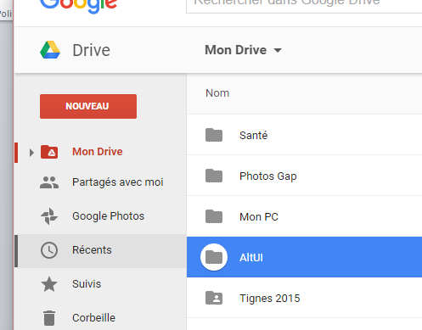

2) for convenience you can have a folder, I use ALTUI

3) choose New Google App Scripts

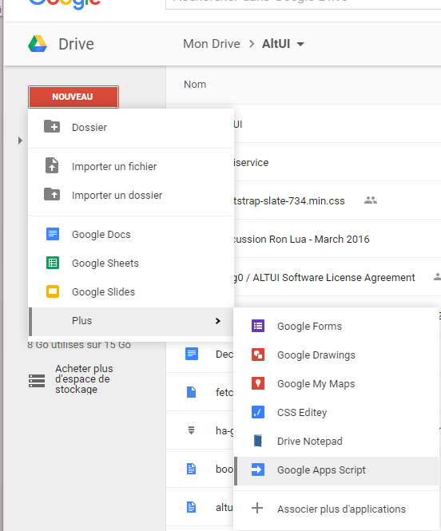

4) Edit your web service code.

Things to know:

* Function doGet(request) is called for GET requests
* Function doPost(request) is called for POST requests
* Input parameters are coming in the request.parameters object

Here is the code to return the same object as the input parameters

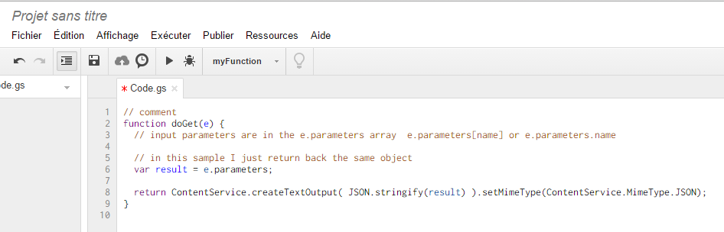

5) Save with File Save

6) Go to File / Manage Version

Create a new version that will be most likely version 1 for now

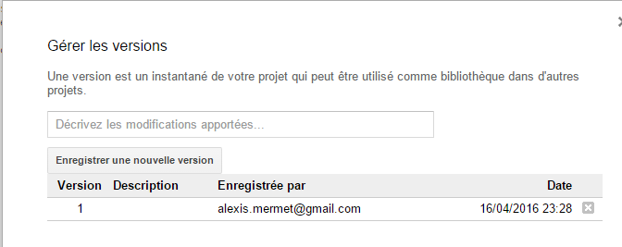

7) Go to publish / Web application

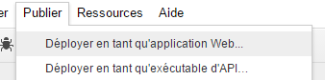

8) Set the proper security parameters

* You want all users including anonymous to have access
* You want the script to execute in a user context, most likely you own one if you want your script to do things like adding data into a google sheet or equivalent.

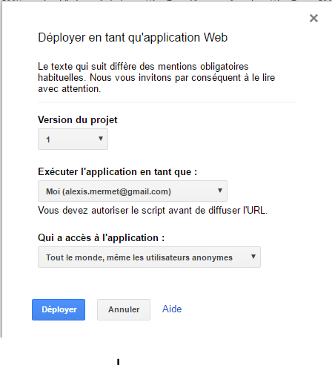

9) click Deploy and note down the URL of the web application

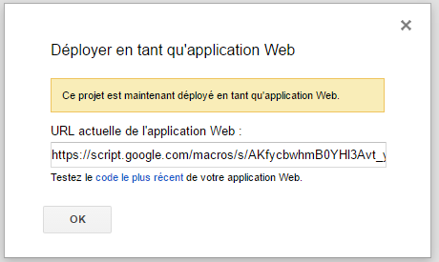

10) open your favorite browser, paste the URL and add the parameters you want



11) see the result… and it also works in HTTPs so with remote access

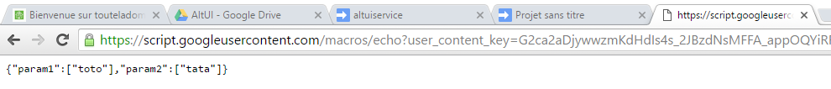

Not to mention that you can do things inside your web service like recording into a DB, checking user licenses etc…